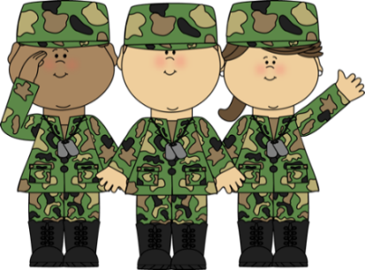
FOCUSED OUTREACH RICHMOND
400 Commerce Road
Richmond, VA 23224
804.419.4184

Veteran 2017–18 Group Schedule
 | MONDAY | TUESDAY | WEDNESDAY | THURSDAY | FRIDAY
10:00 AM – 11:00 AM |  | Campbell’s Computer Literacy
12:00 PM – 1:00 PM |  | Relapse Prevention (Moses) |  | Illness Management and Recovery (Kelly)
1:00 PM –  2:00 PM | Early Recovery Skills (Robin) |  | Stages of Change (Alfreda)
2:00 PM – 3:00PM |  | Mindfulness with Melissa |  | Yoga “Warriors at Ease” (Tonita)  Sponsored by: Nava Life Yoga

Early Recovery Skills (ERS) Group:
The ERS group is focused on two concepts (1) The client has the power to increase the odds of abstinence and the ERS group will help (2) Someone attempting to achieve lasting recovery will benefit from attending community-based groups.

Mindfulness with Melissa:
This group helps you learn to calm your mind and body to help you cope with illness, pain, stress and other dis-ease. Calming is achieved by cultivating an awareness that arises through paying attention, on purpose, in the present moment, non-judgmentally.

Relapse Prevention:
This group focuses on the idea that relapse is a predictable, nonrandom event that is obvious to the therapist and other clients. The goal of this group is to educate the client and identify the signs of relapse early so it can be prevented.

Stages of Change:
This group assesses an individual's readiness to act on a new, healthier behavior, and provides strategies, or processes of change to guide the individual through the stages of change to action.

Illness Management and Recovery (IMR):
This group helps people acquire information and skills to develop more mastery over their psychiatric illness and make progress towards their own personal recovery while emphasizing personal goal-setting and actionable strategies for recovery.

Warriors at Ease:
Yoga is a mind-body practice that promotes health and well-being. Research shows that yoga and meditation can improve one’s response to stress, reduce sensation of chronic pain, improve quality of sleep, create a sense of calm in body & mind, and decrease symptoms associated with PTSD. Access PILOTS (Published International Literature on Traumatic Stress) for research and more information or see www.warriorsatease.org. This class is sponsored by Nava Life Yoga.

